**face-recognisation-by-transfer-learning**

In this project, I have created a Face-Recognition model using the concept of **Feature Tuning**.

***Step 1:*** We start of by collecting our dataset. For this, I have used Haarcascade FrontalFace. I have collected 200 images of mine & my friend for training the model & 100 images each for testing the model. You can use the following code to collect the images and prepare the dataset.

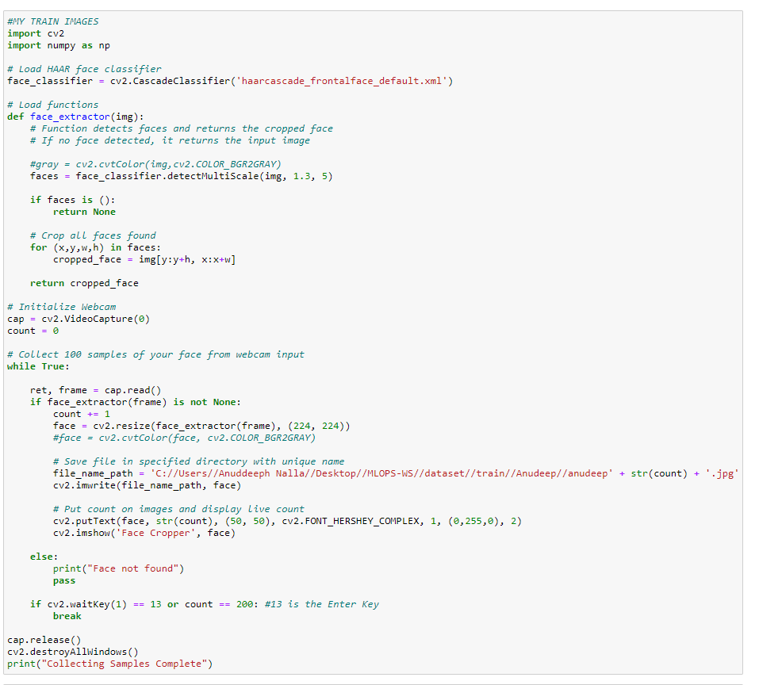

I have used the same block of code multiple times to collect all the training & testing images of me & my friend. You can collect images of more people as per your requirement. For more details check the code

***Step 2:*** Now, we import pre-created MobileNet model from keras.applications. We freeze the already trained layers by layer.trainable= False.

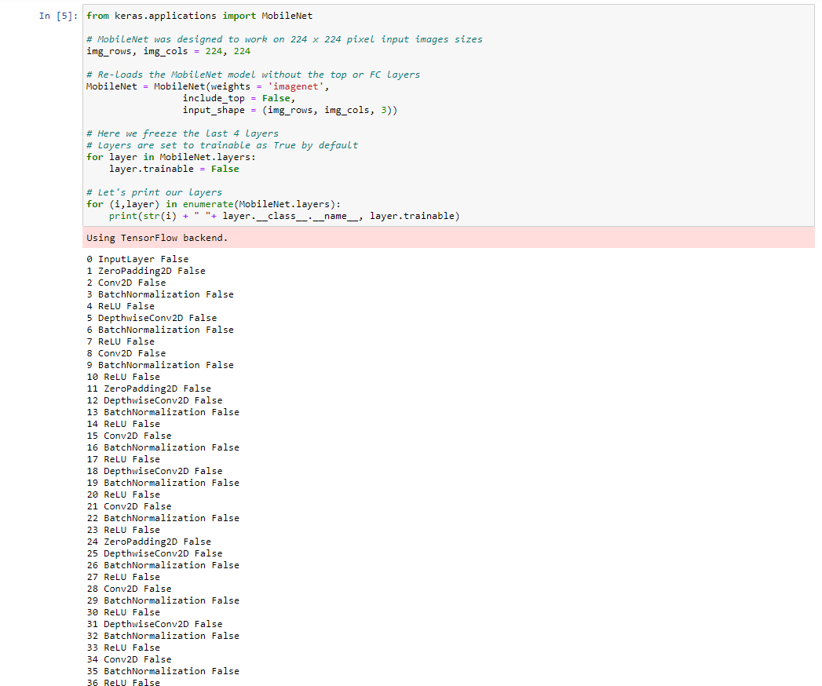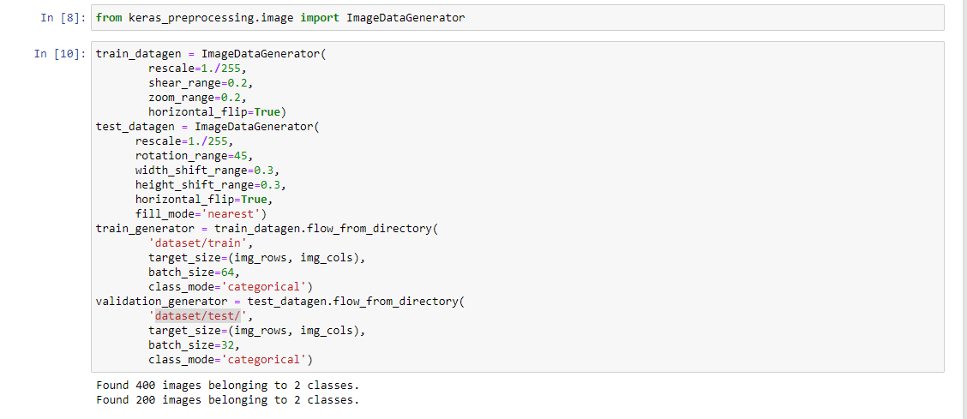

***Step 3:***  We add layers as per our requirement. Here, I have used Softmax activation function.

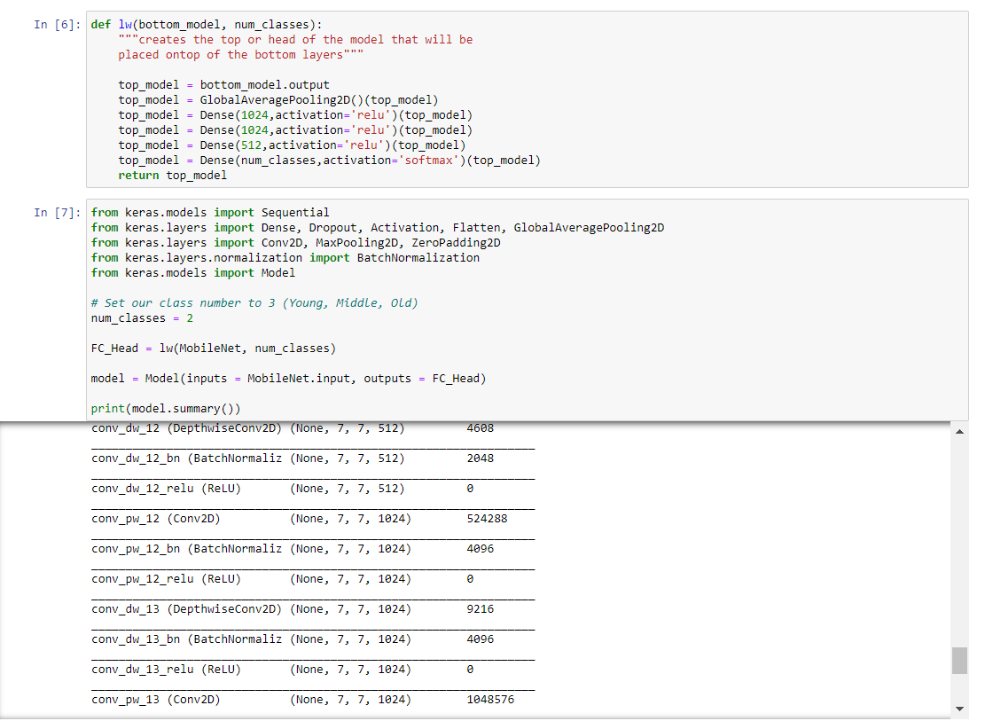

Next, we load our dataset. We have used the augmentation technique to increase our dataset since the size of original dataset is too small for a good accuracy.

***Step 5:*** Now, we begin training our model.

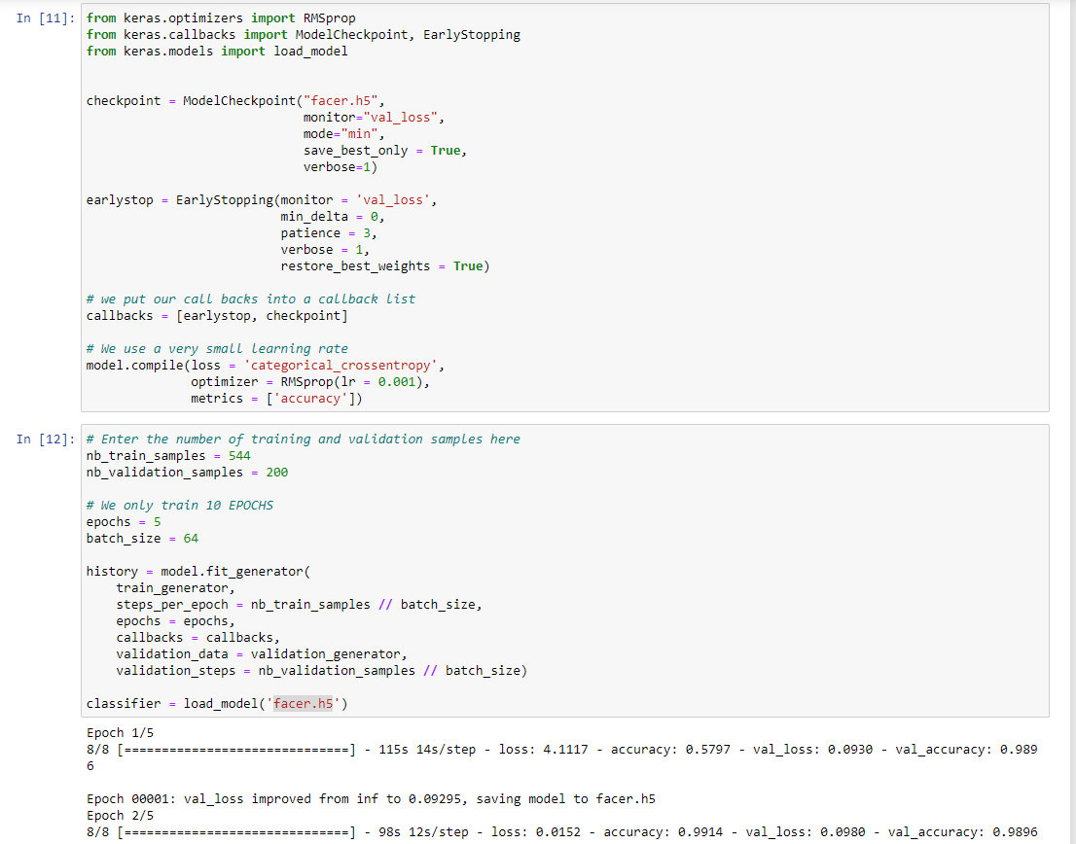

The model has been effectively trained and ready to use. You can use this model for prediction.

In this model, I got 99% accuracy, because the data was very less.

***Step 6:*** Now, I have loaded the created model for prediction, and predicted mine and my friend face.



The output of predicted model:

